08 3 color - full color LED SMD module

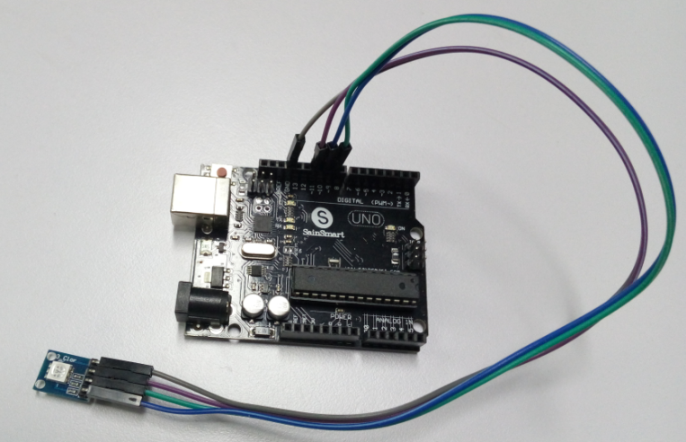

int redpin = 11; // select the pin for the red LED

int bluepin =10; //select the pin for the blue LED

int greenpin =9; //select the pin for the green LED

int val;

void setup() {

pinMode(redpin, OUTPUT);

pinMode(bluepin, OUTPUT);

pinMode(greenpin, OUTPUT);

Serial.begin(9600);

}

void loop()

{

for(val=255; val>0; val--)

{

analogWrite(11, val);

analogWrite(10, 255-val);

analogWrite(9, 128-val);

delay(1);

}

for(val=0; val<255; val++)

{

analogWrite(11, val);

analogWrite(10, 255-val);

analogWrite(9, 128-val);

delay(1);

}

Serial.println(val, DEC);

}